User Instructions:
- Check to make sure DHCP server is running by looking for devices on network. Reboot if needed by holding down power for 8 seconds and then powering up after it turns off.
- Remote into the VXI computer at 192.168.1.207 and make sure Resource Manager has allocated the VXI memory addresses (from inside NI-Max). This computer sometimes locks up and has to be restarted and then Resource Manager run.
- Remote into the Matisse computer at 192.168.1.1XX and make sure the Sirah laser, the wavemeter, and the PID controller are running
- Make sure the X: drive is mounted on the lab PC
- Make sure the COM port assignment software is running on the lab PC
- Open valves to gas lines for gas regulator and turn on pressure regulator (turn off at end of day – set to zero)

DAQ development
- Timing info needs to be dumped to D:/PHASMA_RawData - TR
- Finish writing of raw data to MDS and map MDS (Joergers, MSO5104_01, optical tomography. Thomson, Axial B(z), Gun/trigger timing offsets and gun pressure will be added next - TR).
- Test plasma gun motor drives with DAQ system.
- Confirm that trigger fires fast photodiode system and other devices and that the data from the new digitizers is being written to the PHASMA raw data directory.
- Interlock reinstalled for parallel TS and light baffling improved. Beamline is still exposed. Record photodiode signals with Rigol scopes
- Expand timing #1 trigger A for laser warmup to provide a trigger to all three pulsed YAG lasers (TS para, TS perp, PLIF)
- Make sure the LeCroy scope transfers data.
- Organize the different MatLab/Python codes that will plot data from different diagnostics (Tom is organizing this) (Nowhere near functional yet; need volunteers to help develop submodules such as porting bdot plotting functionality to python. Jscope will work fine in the meantime – TR 1/15/2025)

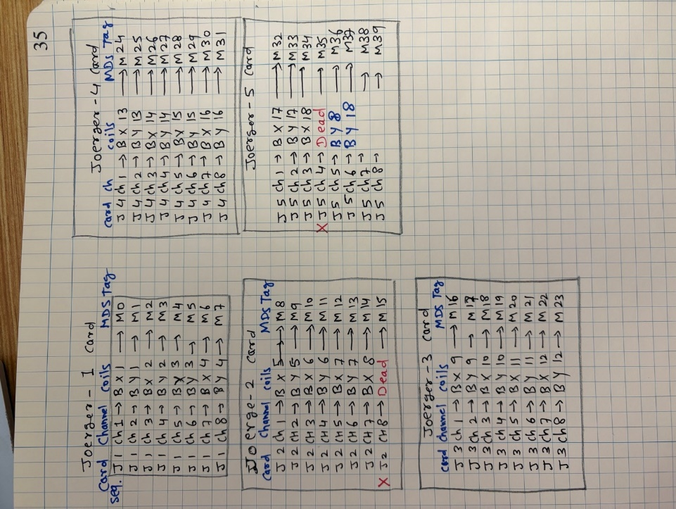
Phasma MDSplus implementation as of 1/15/2026
Work in progress. Currently writes some devices to mds but not all. Adding more is quick due to the magic of OO. Not sure if its budled conda environment will work with labwindows Python; if it doesn’t this code can also called as executables targeting its local interpreter.
Raw data from C:/ drive is pushed to the MDS server (Phasma2025) using a self-contained Python environment located at C:\PHASMA 2025 DAQ\PHASMA Python Routines\PHASMA_C_to_Python_convertor_Project\PhasmaMDS
This code is bundled with its own conda environment, libraries included, so it is completely static with no external dependencies.
To write the current shot data MDS, call push_all_mds_latest() within mds_push_all.py and it will attempt to find devices it recognizes a from that shot inside C:/Phasma_RawData. Reads the current shot by asking the mds server which in turn refers to shotid.sys in the Phasma2025 mds folder. Does not increment shot.
Contains code to easily modify the shot tree if/when new instruments are added. No more manually adding 48 channels in Jtraverser. Will expound on this more later

